EVERY QUESTION MUST BE READ CAREFULLY AND ANSWER WHAT IS ASKED. PLEASE USE APA FORMAT (IN TEXT CITATION AND THE WORK CITED AT THE END OF THE PARAGRAPH). HIGHLIGHT THE QUESTIONS THAT ARE BEING ASKED AND RESPOND RIGHT UNDER IT IN A PARAGRAPH FORM. ONE TO TWO CITATIONS MINIMUM (NO MORE THAN 4 IF NEEDED). EVERYTHING IS WRITTEN CLEARLY. I REPEAT, EVERY QUESTION SHOULD BE WITH A CITATION.
EVERY QUESTION SHOULD BE ANSWERED THOUROUGHLY AND DETAILED. DO NOT ANSWER BACK WITH A FEW SENTENCES.

Question 1:
This week, explain the various responsibilities and services of FEMA when a disaster occurs in the United States. Do some research on past disasters, and describe how FEMA supported the community and disaster efforts. Address 2-3 of the following.
- How did FEMA help people prepare for the disaster?
- What services did FEMA provide to the community?
- Who else participated in the disaster relief efforts?
- How much monetary damage was caused by the disaster? Or, how much did FEMA spend in relief?
- What was public perception of FEMA and the response they provided?
Provide links to your sources for others to reference.
Support your answer with evidence from the disasters that you researched.

Question 2:
View this video link and answer the following bullet point questions.
https://www.youtube.com/embed/zP4rgvu4xDE?rel=0
- What are some of the nursing implications of this disaster?
- What diseases do you need be concerned about and how would you protect yourself and others? Be specific.

Question 3:

First, review the two attachments on the following page:

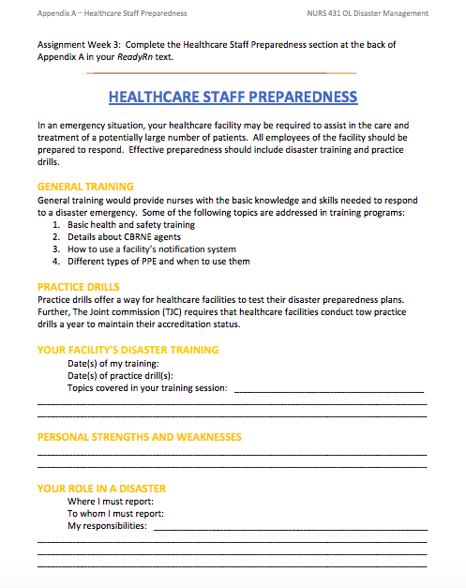

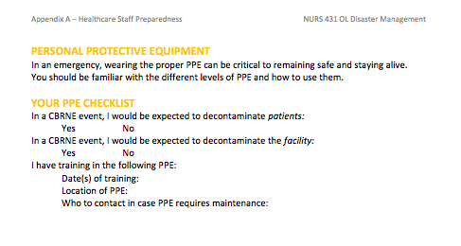

Next, at your current hospital or clinical setting or a hospital where you currently work conduct a scavenger hunt (online or on ground) for the emergency protocol information. Find out the information to answer 2 of the questions below. Choose two (2) of the following to discuss:
- Is there an emergency manual for your facility?
- Have you read it?
- Was it included in your training or orientation?
- Who are the disaster management leaders (titles/positions, not personal names)?
- Where are the designated safe locations in the event of a natural disaster?
- What is the procedure for lockdown?
- What are the decontamination procedures for biohazards?
- What is the Ebola protocol?
- When was the last disaster training, and have there been any practice drills?
- Do you know what role you would take in a disaster situation?
- What is the trauma level designation?

Write the question you picked – then answer it (for both)

Question 4:

For this week's discussion, we will be looking at local or national response protocols that were initiated during a critical incident, and you will choose your topic!
Search reputable local and national media for a man-made disaster to discuss.
Search for critical instances such as: hostage situations, mass shootings, multiple-vehicle or mass transit accidents with multiple critical injuries, and disease outbreaks.
In your initial post, describe the incident and address the following:
- Determine the incident type and explain your reasoning.
- What resources were deployed for this incident?
- What protocols were implemented successfully, and which were unsuccessful?
- Discuss way to improve the response to this type of incident in the future.
Support your answer with evidence. ​ Please provide a working link to your story source.
Question 5:

For this week’s discussion, you are asked to research a natural disaster. In your initial post, describe the incident, describe the incident and answer the following questions in your response.
- What type of evacuation protocol would this incident require? Discuss hospital evacuation or community evacuation processes.
- What type of nursing assessments would be required for the victims of this incident?
- What nursing interventions would be a priority for these victims?
- What community resources should the nurse provide to the victims for follow up treatment?
Support your answer with evidence. Please provide a working link to your story source(s).

Question 6:

This week, read the journal article "Challenges and Resources for Participating in a Hurricane Sandy Hospital Evacuation" and complete the activity below.

PLEASE LOOK AT THE ATTACHMENT NAMED “HURRICANE SANDY ARTICLE – QUESTION 6” FOR THIS QUESTION!

After completing the activity, discuss your role as a nurse in disaster preparedness and response. Describe your current patient population and discuss the challenges you might face in carrying out your responsibilities in a disaster.
How could you gain more hands-on training to supplement your academic study of disaster management? How could you feel more prepared? Discuss different training options that you could participate in (e.g., CERT training).

Question 7:

This week you will put together your 72-hour disaster home "go bag" and evaluate your preparedness.
Here are the steps for your initial post:
- Use the lists available at https://www.ready.gov/build-a-kit , https://www.fema.gov/media-library/assets/documents/90354 , OR http://www.redcross.org/flash/brr/English-html/kit-contents.asp to gather items for your 72-hour home go bag. Add additional items that you think will be useful and essential for your family.
- 2. Post a picture of all of the items you have gathered for your go bag. For the sake of personal and family privacy, keep personal/private items out of the photograph; you may list them (e.g., prescription medications).
Along with your photo, include the following information:
- A list of the items in your home go bag
- A brief explanation of the demographic considerations and potential disaster hazards in your area and why you included certain items
- Your family, pets, and living situation considerations and why you included certain items
- Are you prepared to help others in your community in the event of a disaster?

Question 8:
Review the American Nurses Association (ANA) Code of Ethics to address the questions below
PLEASE LOOK AT THE ATTACHMENT NAMED “CODE FOR ETHICS”. THEN answer the following questions:

- Does the law require you to respond in disaster situations?
- Do RNs have a contractual responsibility to respond in disaster situations?
- Are you familiar with the laws in your state?

Question 9:

Research and investigate whether Hollywood Presbyterian Medical Center (hospital in Los Angeles, CA) has a critical instance stress management (CISM) team in place, and what department oversees it. Share what you learn. What are the benefits of having CISM?

Please make sure your work follows the rubric below:
